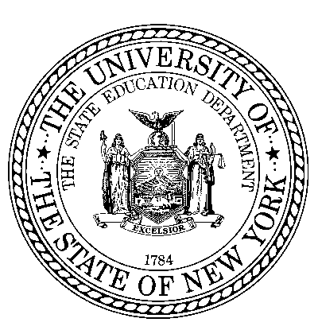
THE STATE EDUCATION DEPARTMENT / THE UNIVERSITY OF THE STATE OF NEW YORK / ALBANY, NY 12234

Kathleen R. DeCataldo, Esq. Assistant Commissioner Office of Student Support Services
89 Washington Avenue, Room 318-M EB Phone: (518) 486-6090
Email: StudentSupportServices@nysed.gov Web: http://www.p12.nysed.gov/sss/

Date: March 5, 2020

To: District Superintendents Superintendents of Schools
Administrators of Charter and Nonpublic Schools

From: Kathleen DeCataldo, Assistant Commissioner of Student Support Services

Subject: Handwashing Recommendations and Alcohol-based Hand Sanitizer Use in Schools

This memorandum updates the State Education Department’s 2009 guidance on the use of alcohol-based hand sanitizers in the school setting. The earlier memorandum in response to the H1N1 pandemic informed schools that the school district Director of School Health Services (a.k.a Medical Director) may approve and permit the use of alcohol-based hand sanitizers for use in their facilities without individual’s physician orders; as alcohol-based hand sanitizers are considered over-the-counter drugs by the United States Food and Drug Administration. Additionally, we are providing additional information to schools on handwashing to review when developing their protocols and plans. This guidance is based on best practice in infection control and recommendations from the Centers for Disease Control and Prevention (CDC).

Hand washing is the best way to prevent the spread of disease. Schools should promote hand hygiene to decrease the spread of disease in the school community. This can be accomplished by education of proper hand hygiene, posters, bulletin boards, communication to parents, through morning announcements, and in curriculum as appropriate. Schools should provide adequate facilities for hand washing which includes soap, paper towels or hand dryers, and trash bins for disposal of paper towels. During periods of high rates of transmission of disease such as the flu, schools should permit students time to wash their hands after using the restroom, before meals- and after if needed, after recess or physical education, before and after using electronic devices that are used by multiple students, after coughing or sneezing, and other times as appropriate.

If soap and water are not available, alcohol-based hand sanitizers (with at least 60% alcohol) are an effective alternative for cleaning hands and are recommended as an alternative to soap and water by the NYS Department of Health. Student use of alcohol-based hand sanitizers should always be supervised by adults. Parents/guardians should be informed of the use of hand sanitizers and allowed to opt their child out of using it by sending a written notice to the school.

1
Please note that hand sanitizers contain alcohol and are flammable. They must not be placed in hallways, or near an open flame or source of sparks (e.g. science labs with Bunsen burners or shop classes) If you require further guidance please contact your BOCES health and safety staff, the State Education Department’s Facilities Planning Office or the State Office of Fire Prevention and Control .

For a fact sheet and further information on the use of alcohol-based hand sanitizers in schools please visit the New York State Center for School Health’s website at https://www.schoolhealthny.com/coronavirus and under A-Z Resources under H hand sanitizer.

Additional Resources

Centers for Disease Control and Prevention:

• CDC Health Promotion Materials, includes downloadable posters; • Information on proper handwashing technique; and
• tips for families to help children develop good handwashing habits

New York State Department of Health:
• Handwashing poster for primary schools (also in stock in Distribution Center); https://health.ny.gov/publications/7220/ English https://health.ny.gov/publications/7221.pdf Spanish

• Handwashing decals for employees: https://www.health.ny.gov/publications/3227.pdf English, https://www.health.ny.gov/publications/6540.pdf Spanish https://www.health.ny.gov/publications/6541.pdf Chinese

• Adult handwashing materials: https://www.health.ny.gov/publications/7096.pdf

2

