Universal Pre-K Program

Phone (607) 757-2291 Fax: (607) 757-3439

January 2, 2020

Dear Parent/Guardian,

We are pleased to inform you that the Vestal Central School District is planning to continue its UPK Program for the 2020-2021 school year, contingent upon the receipt of grant funding from New York State.

New York State includes funding for UPK programs to “provide four-year-old children with a universal opportunity to access high quality pre-kindergarten programs that prepare them for future success by developing strong foundational skills in literacy and numeracy.” Eligible children must be district residents who will befour on orbefore December 1 of the yearin which they are enrolled. Transportation is not provided.

The grant would allow 99 Vestal UPK students to attend a half-day program. If the district receives more than 99 applications we will conduct a required lottery to pick students randomly. Students not selected will be placed on a waiting list and parents will be notified as openings become available.

If you are interested in having your child attend our UPK Program for the 2020-2021 school year, fill out the enclosed application, along with two proofs of residency, and return it to the address at the bottom of the form as soon as possible. Please see the reverse side of this letter for a list of acceptable documents. If you have any questions, please do not hesitate to contact the Vestal Central School District at 757-2291 or me at lmlamash@vestal.k12.ny.us.

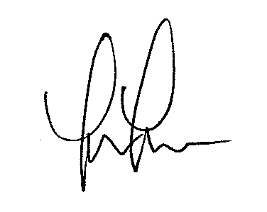
Sincerely,

Laura Lamash, EdD
Assistant Superintendent for Instruction

LL/sm Enc.

Proof of Residency

Upon registering, the District requires two forms of documentation to establish residency and can include, but is not limited to:

➢A copy of residential lease or proof of ownership of a home, such as a deed or mortgage statement
➢A statement by a third-party landlord, owner or tenant from whom the parent(s) or person(s) in a parental relation leases or with whom they share property within the district, which may be a notarized affidavit
➢Other forms of acceptable documentation can be used as well, such as: ✓Pay stub
✓Income tax form ✓Utility or other bill
✓Membership document based on residency ✓Voter registration document
✓Official driver’s license, learner’s permit or non-driver identification ✓Documents issued by federal, state or local agencies (such as from a
local social services agency)
✓Evidence of custody of the child, including but not limited to judicial custody orders or guardianship papers
201 Main St.
Vestal Central School District

UNIVERSAL PRE‐KINDERGARTEN (UPK) Application for Enrollment 2020‐2021

Student’s Name: ______________________________________________________________________ First Middle Last
 Boy  Girl Date of Birth: ____________________________________________ (Please note: Student must be 4 years of age on or before December 1, 2020)

Street Address: _____________________________ City: ________________ State:_____ Zip: ______ Parent/Guardian Name: ________________________________________________________________ Home phone number: ___________________ Work: ________________ Cell: ___________________ Email address: _______________________________________________________________________

Check the Elementary School you anticipate your child will be attending during 2021‐2022 school year:

African Road Elementary Clayton Ave. Elementary Glenwood Elementary

 Tioga Hills Elementary Vestal Hills Elementary

Please enclose two proofs of residency with this application.

Parent/Guardian Signature ________________________________________________

Date: ________________

When the site review process is completed you will be notified of the locations. At that time, you will be given the opportunity to confirm your preference for location and half‐day.

The Vestal UPK Program is dependent on funding from New York State. Transportation is not available.

Please Return Completed Application to: Vestal Central School District
757‐2291 Attn: UPK Program 757‐3439 (fax) Vestal, NY 13850

